MIS 311 – Introduction to Business Analytics
Part 1 – Data Analysis and Insight
Dataset: Student Exam Performance
Prepared by: Luu Hung Phuong Thuy
IRN: 2232300251
1. Data Overview
The dataset used for this analysis is the Student Exam Performance dataset, provided as part of the MIS 311 course materials at Eastern International University (EIU).

Attribute | Details
Source | MIS 311 Course Dataset – Eastern International University
Number of Rows | 10,000 student records
Number of Columns | 23 variables
Key Variables | study_hours_per_day, attendance_rate, final_exam_score, previous_gpa, pass_fail, grade_category, math_score, reading_score, writing_score, science_score
Context | Tracks academic behaviours and performance outcomes for 10,000 students, including demographic details, study habits, and exam scores.

2. Data Cleaning
2.1 Missing Values
Each of the 23 columns was checked for missing values using Excel's COUNTBLANK() function. The result confirmed that all 10,000 rows are complete with no missing entries across any column.
Since there are no missing values, no imputation or row removal was required. The dataset is complete and ready for analysis.

2.2 Duplicate Rows
Duplicate rows were checked using Excel's Data → Remove Duplicates feature, selecting all data.
Result: No duplicate records were found. Each row represents a unique student identified by a distinct student_id. The dataset requires no further cleaning.

3. Descriptive Statistics
Descriptive statistics were generated using Excel's Data Analysis ToolPak (Descriptive Statistics function) for four key numerical variables:
study_hours_per_day, attendance_rate, final_exam_score, and previous_gpa.

Insight 1: Study Hours Per Day Is a Strong Predictor of Pass/Fail Outcomes
The analysis compared the average daily study hours between students who passed and those who failed. The PivotTable in Excel revealed a clear and meaningful gap between the two groups.

Row Labels | Average of study_hours_per_day
Fail | 2.467934656
Pass | 3.603725813
Grand Total | 3.019702

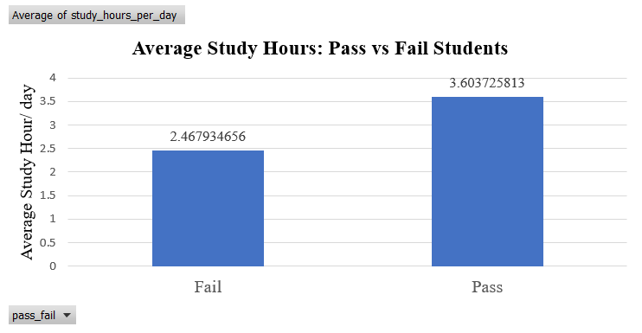
Figure 1: Average Study Hours per Day by Pass/Fail Outcome
Students who passed the exam studied an average of 3.60 hours per day, compared to only 2.47 hours for those who failed, a difference of over 1 hour per day. This gap of approximately 46% more study time suggests that daily study habits are a critical differentiator between academic success and failure. From a business analytics perspective, this finding implies that targeted interventions such as study time reminders or structured study plans, could significantly improve student pass rates.

Insight 2: Attendance Rate Is Consistently Higher Among Passing Students
Using a second PivotTable in Excel, the average attendance rate was compared between students who passed and those who failed. While the absolute difference appears small, its consistency across 10,000 students makes it statistically meaningful.

Row Labels | Average of attendance rate
Fail | 83.50532867
Pass | 85.97227254
Grand Total | 84.70377
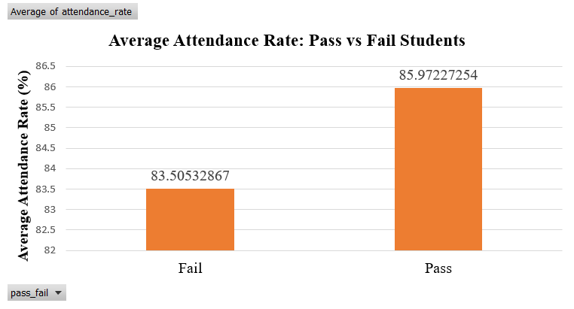
Figure 2: Average Attendance Rate by Pass/Fail Outcome
Passing students attended an average of 85.97% of classes, while failing students averaged 83.51% that a gap of 2.46 percentage points. Although this difference may seem modest, when observed across a sample of 10,000 students, it indicates a consistent pattern: students who show up more regularly are more likely to succeed academically. This insight highlights that attendance is not merely an administrative metric, but an important behavioral indicator of student engagement and academic outcomes.

References
Eastern International University. (2025). MIS 311 – Introduction to Business Analytics: Assignment #1 dataset [Student Exam Performance]. Course materials provided via Moodle.

